Name

Today’s Date

There are 9 controls for you to find on this Adventure Challenge

Primary Schools Workbook


Control Point 1 – Data Collection

This activity runs throughout the trail. As you go around the course, collect a tally on the number of waymarker posts (only the ones with arrows marking walking routes) and orange directional arrow discs. Use this table to keep a record as you go. Keep your eyes peeled!

 | Tally | Total
a) Waymarker posts
b) Orange discs

When you have completed the trail, work out:

If one waymarker post costs €12 and one orange arrow disc costs €4, what would be the total cost of waymarker posts and arrow discs?

Waymarker posts € ________

Orange arrow discs € __________

c) Total cost of posts and discs € ____________

Control Point 2 - The Compass

Can you spot Three Rock Mountain in the distance – the one with the television masts on top of it?

- How many masts are visible? __________

- What direction is Three Rock Mountain? __________

Hint: Orientate your map correctly and look at the compass at the top left corner to help determine the direction.

- If each mast is 20m tall, what is the height if all the masts were stacked on top of each other?
___________________

Remember to look out for waymarker posts and orange arrow discs!

Control Point 3 – Fencing calculation

What is the area of the forest enclosed within this fence, if one side measures 200m, and the area is square in shape?

________________________________________

How many metres of fence are required to enclose the entire area?

Remember to look out for waymarker posts and orange arrow discs!
Control Point 4 – How old is that tree?

Trees are the longest-living of all plants with some species living for thousand of years. If you know when a tree is planted in Carrickgollogan, you can easily and accurately determine its age. But how do you tell its age if you don’t know this information? Although trees grow at different rates you can estimate the age of a living a tree, by measuring the circumference of its trunk (girth) – the older the tree, the greater its girth. On average, trees in Ireland increase their girth by 2.5cm a year.

Look at the pine tree with the yellow painted dot on it. What age do you think this tree is? Have a guess!

_______ years old approximately

Now for some measurements to figure out its actual age:

Experiment 1:

Using your measurement tape, measure the circumference of the tree trunk, at the standard height of 1.5 metres above the ground. If the ground is uneven, measure on the upper side of any slope. remember to change your measurement to centimetres.

What is the circumference of your tree’s trunk?

cm/2.5cm =
years old approx.
Why are you dividing by 2.5cm? _____________

Do you need to make any adjustments because of its species or the thickness of the bark? YES / NO

Why? ___________________________________

Experiment 2:

This same pine tree has layers of branches (whorls) up the trunk.

How many whorls are there?

= years old approx.

Control Point 5 – Lead Mines Tower

From this point walk a further 100m north along the trail to the Lead Mines Tower.

From the early 19th century, up to the 1920s lead and silver were mined here. Ore was also brought from Glendalough for processing here. In front of you, you can see the granite chimney of the Ballycorus lead mine. The top third of the tower has been removed for safety reasons.

What do you think was the purpose of the chimney? ________________________________________
________________________________________
________________________________________

What do you think lead was used for back in the early 19th century?
________________________________________
________________________________________
________________________________________

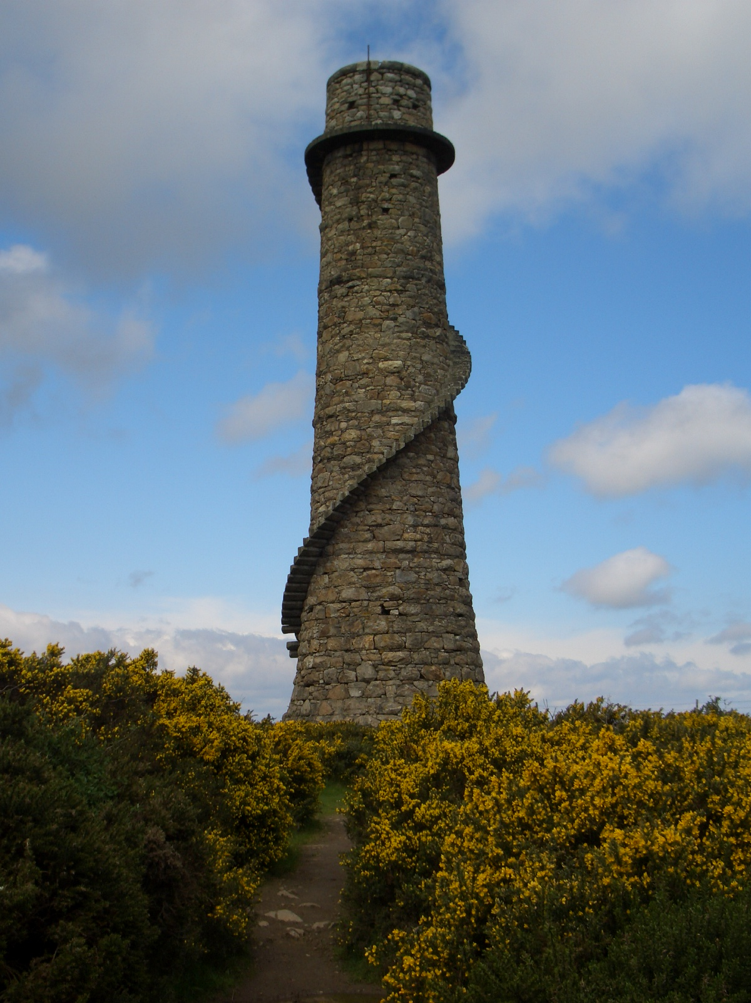
Now walk back to the post at control point 5.

Control Point 6 – Energy

What are you standing under here?

________________________________________

What is the voltage of this power line?
________________________________________

What symbol is used to show this feature on your orienteering map?

Suggest three ways how you can save electricity in your home and help save the environment.

- ________________________________

- ________________________________

- ________________________________

Control Point 7 – Electrical transmission

Here the power line is supported by wooden posts.

How many wooden posts can you see from this point? _________________

Martin has to paint each post so it does not rot. If it takes one and a half pots of paint to paint each post, and there are 10litres of paint in each pot. How many litres of paint does Martin need to paint all the posts?

Number of wooden posts? ____________

Total number of pots of paint required? ________

Number of litres of paint in each pot? _________

Total number of litres of paint required? _______

Remember to look out for waymarker posts and orange arrow discs!
Control point 8 – How old is that tree?

Look at the log under the big tree to your left. The age of a tree can be measured accurately after it has been felled, by counting the growth rings. Some of the rings are much wider than others. In other words, the tree grew more in some years than in others.

Why do you think this might be?
________________________________________________________________________________

Each ring is a layer of wood that took a season to grow i.e. each year has a light ring (springwood) and dark ring (summerwood) together. Trees do not grow at the same speed all year. In which season do you think trees in Ireland will grow most? Why?
________________________________________________________________________________

To find the age of the tree when it was cut down just count the dark rings. So this tree is how many years old? ___________

If this tree was cut down in 2006, what year was this tree planted? _____________

Control Point 9 – Tree planting calculation

On your way to this control you passed a fenced area. Woody the forester wants to plant trees in this forest which he has divided into 6 blocks. Using the following information, answer the questions below:

- Each block of forest takes 50 trees
- Trees cost €50 for 100 trees
- It takes 1/2 hour to plant 50 trees

- How many trees will be needed? _________

- How much will they cost? _____________

- How long will it take to do all the planting? ______________

Diagram of the forest area

